Able Seaman George Calvert
George was born on the 14th January 1885 in Darwen, the second son of William and Maria (known as Marcia) Hill. He was baptised on the 26th March 1885 at Bolton Road Wesleyan Church, Darwen.
At the age of 29 he was a cotton weaver and lived at 5 Ivy Terrace.
He married Jane Fish, aged 26 a Confectioner of 443 Bolton Road, at Bolton Road Wesleyan Church on 10th March 1914. (Her parents were William Fish and Betty Atherton.)
It was reported in the DARWEN NEWS & GAZETTE on the 23rd March 1918 - An intimation has been received at his home in Northcote Street that A.B. (Able Seaman) George Calvert of the Royal Naval Division is now in hospital abroad suffering from gas poisoning. He is one of four brothers who joined the forces and one as been killed.
It was then reported in the DARWEN NEWS on the 4th May 1918 - News reached Darwen yesterday that Private G Calvert of Northcote Street was badly gassed serving in the seat of war and removed to Hospital in Nottingham were he passed away. He was married and leaves a widow but with no children. The second son of William and Marcia Calvert of 5 Ivy Terrace, he made the supreme sacrifice.
His Service Record states, he joined up on 13th June 1917 and was drafted to BEF on the 17th December 1917. He joined Anson Battalion on 5th January 1918 - 12th March 1918. Gassed and invalided to the UK on 14th March 1918.
He was buried on the 8th May 1918 in Section 4 Plot 1070 where his wife joined him on the 13th December 1937 (she committed suicide).
Bolton Road United Reformed Church has a memorial to him and his two brothers William Henry (born 1888 - died October 1917 in Belgium and Herbert (born1890 - died 26th October 1918 in France. Another brother Norman served in the Irish Guards and later worked for the Darwen Gazette he died on the 6th February1938 at Southport Infirmary.
(information Courtesy of Teresa Watson)

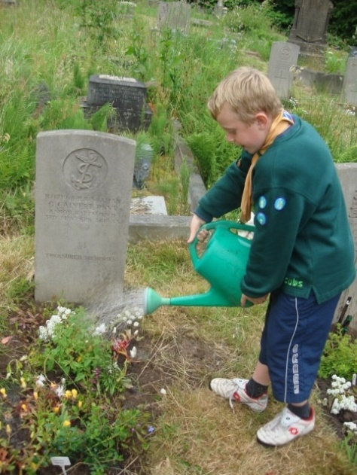
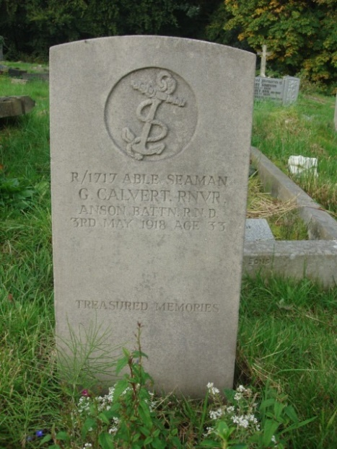

George Calvert's Grave has been adopted by Whitehall Scout Group together with 5 other War Graves all in Section 4B of the Cemetery

