Our Australian Soldier
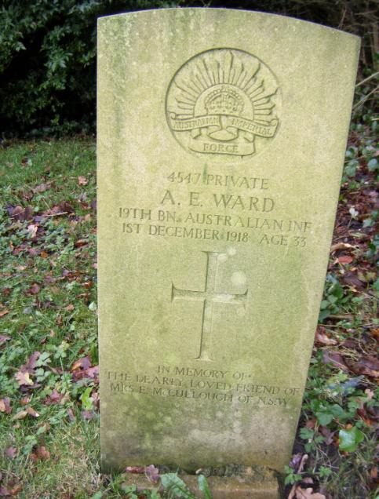
Alfred Edmund WARD

Alfred Edmund WARD Alfred Edmund Ward (Ernest) was born in Wallangra near Warialda, New South Wales, Australia in June 1877.
His parents were John and Henrietta Ward. Warialda (aboriginal for ‘place of wild honey’) is a small rural town on the northern edge of NSW bordering Queensland. Warialda is only 25 miles from a place called Myall Creek which is synonymous with an aboriginal massacre which happened at a sheep station in the 1830s as land was taken by European white settlers.
Although he was born near Warialda it is doubtful he spent much time growing up here as he is documented as attending school at Cleveland Street Public School, Sydney. This school is in the suburb of Surry Hills where he resided at a boarding house belonging to Mrs Evelyn McCullough of 130 Devonshire Street.
Devonshire Street, Sydney was the site of the old cemetery where early pioneers and convicts were buried. In 1901 the headstones were relocated for the expansion of Sydney Central Railway Station. Ernest worked as a labourer at this time and it is possible he worked on the expansion of the Central Railway Station.
During the Boer War Ernest served with the NSW Imperial Bushmen Unit and must have been around 23 years old when he enlisted. The
NSW Imperial Bushmen Unit served from May 1900 until 11th June, 1901. The only record for an Alfred Edmund from Warialda is as follows (although his birth certificate has his name as Ernest Edward Thomas Ward).
Boer War Nominal Roll - Alfred Edmund Thomas Ward
Service number: 422 Rank: Private
Unit: NSW IMPERIAL BUSHMEN
Conflict: South Africa, 1899-1902 (Boer War)
State: NSW
Source: Murray page number – 93
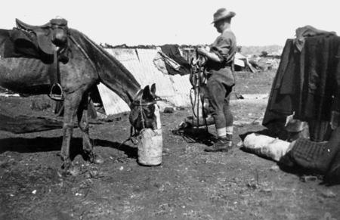

In the NSW Imperial Bushmen camp, South Africa, 1900

He stayed on in South Africa and worked as a Trick Rough Rider in Texas Jack’s Wild West Show at Fillis’ Circus. In his military records from WW1 it states that he worked in a circus as a ‘rough-rider, cowboy’ and states ‘he is believed to be one of the smartest at these performances ‘. He toured with the circus both within the Commonwealth and South Africa.

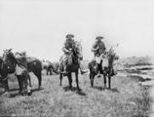
His horsemanship must have enabled him to become an effective soldier in the war.

He continued in the circus on his return to Australia but must have settled back into life at Surry Hills, Sydney because in 1907 his Boer War Medals were sent to Sydney. When Ernest enlisted in the AIF he gave his age as 30 years old, he would have been 39 years old. At Devonshire Street Ernest shared lodgings with William James Harpur (Jacky), a shearer who had worked on the Queensland Border not far from Warialda.
Jacky Harpur joined the same Battalion 19th Bn, 11th Reinforcement and although they enlisted on separate days, they both sailed from Sydney on the HMAT Nestor (Liverpool) on 9th April 1916.
William James Harpur was killed in Flers, France as he was hit by a shell, he was killed instantly along with a comrade. Ernest continued with the 19th Bn until 1918 when he was granted leave whilst serving in France. He decided to visit family in England and stay with his cousin J H Leech.
It was whilst he was on leave in Darwen that he succumbed to influenza pneumonia and died at Vale Mount House, Spring Vale (the home of his cousin J H Leech) on 1st December 1918. He was accorded a full Military Funeral with a firing party, bugler and pall bearers. His age at death is given as 33 years old on his headstone but he must have been aged 42 years.
With no apparent relatives in Australia his landlady Mrs Evelyn McCullough commissioned his grave in Darwen. In his WW1 soldier’s Will Ernest left everything to his landlady and his kitbag contents were sent to her after his death. Mrs E McCullough died May 28, 1938 aged 72 years and her children are listed as Harold, Alma, Gladys and Dorothy (there was no mention of a husband in the records). In fact, Ernest had a brother Robert born in Rockhampton and who was living at Marada, Stonehenge, Queensland after the war and from where he claimed Ernest’s WW1 medals, death plaque and memorial scrolls. So, what was Ernest really called? Birth certificate – Ernest Edward Thomas Ward Trace our Anzac’s website – Alfred Edmund Thomas Ward Death registered as Alfred Ernest Ward (aged 42) .
Nicola Jackson Malabar, NSW Updated December 2010

