Wilkinson, Harold

Born: c1895

Married: 1917 to Kate Dunkinson at Holy Trinity

Died: 4th March 1919 at Darwen

Darwen News, Wednesday 12th March 1919

Darwen Soldier's Death

Winner of Croix de Guerre and Military Medal

The remains of the late Lance Corporal H Wilkinson, son-in-law of Mr and Mrs Dunkinson, of Radford Head, were interred at the Darwen Cemetery on Saturday afternoon with military honours. Deceased soldier, who had been awarded the French Croix de Guerre and the Military Medal for bravery in the field, was released from his unit in French and returned home a month ago, but was suffering from pneumonia and died on Tuesday of last week at the age of 24 years. Enlisting in 1914, he was sent to France with an East Lancashire Regiment, and although wounded twice he remained in France until early last year when he was again wounded. For some time he was in hospital in England was sent out again last June. Before enlisting he was employed as a moulder at Hoddlesden Pipe Works and attended Holy Trinity Church.
A firing party from Preston, under Sergeant-Major Healey, preceded the cortege to the Cemetery where a service was conducted by the Rev A Botterill MA. At the close volleys were fired and the "Last Post" sounded. The mourners were:- Mrs H Wilkinson, Mr and Mrs W Dunkinson, Sergeant and Mrs G Dunkinson, Corpl T Dunkinson, and Pte L Dunkinson, Pte and Mrs J Smith, Miss J Dunkinson, Miss B Dunkinson, Mr and Mrs Slater, Mr and Mrs T Bury, Mr and Mrs C Parkinson, Mrs R Parkinson, Mr and Mrs J Dunkinson, Mr and Mrs B Dunkinson, and Mrs R Duckworth.

[His death was recorded as "pneumonia"; this could have been the result of the Spanish Flu]

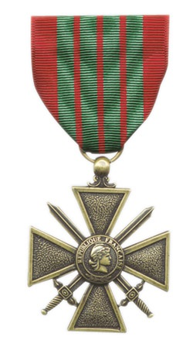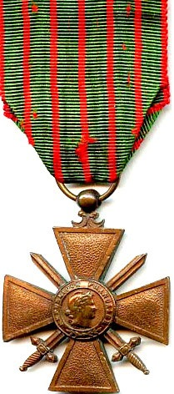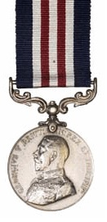

Croix de Guerre Military Medal
His name appears on the War Memorial in Holy Trinity (now St Peter), Darwen.
Thanks to Tony Foster November 2011

