YATES William

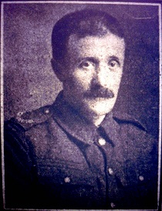

William was born at Farington in 1875, the son of Richard Bailiff Yates and Elizabeth Wilding, and baptised at St Paul, Farington on December 19, 1875.
The family lived at 7 School Street and by the
time of the 1881 census he had commenced working as a cotton weaver.
Between 1901 and 1911 the family moved to Darwen and the family settled in Sudellside
Street, Darwen and William was working as a cotton packer at Olive Mill.
Just before the war he had taken up a job in Manchester.

He attended St James' Church and was a well-known member of the cricket team. On April 2, 1916 he married Mary Alice, daughter of William Ainsworth at St James.

It is unclear as to when he joined the army but it is possible that this took
place in early 1916.
According to the Commonwealth War Grave Commission website he joined the Border Regiment (No. 24471) and then was transferred to the Labour Corps (No. 35292).
However, from the Medal Roll shows that he initially joined the Cheshire Regiment (39634).
He went to France in May 1916 and served as a stretcher-bearer to his Battalion.
In early November he was taken ill and was transferred to Birmingham where he underwent two operations and he died shortly afterwards.
His body was returned to Darwen and he was buried in Darwen Cemetery on January 17, 1918.
Prior to WW1 William had seen service in the South African War
(1899-1901) in the Royal Army Medical Corps.
At the end of the war his widow received his war medals - Victory Medal and the British War Medal.
Grave Ref: Section K.304 (OS Ref: SD 69811,20308)
Thanks to Tony Foster - November 2011
updated September 2013

