Lieutenant George Robert Craig M.C.44 Squadron

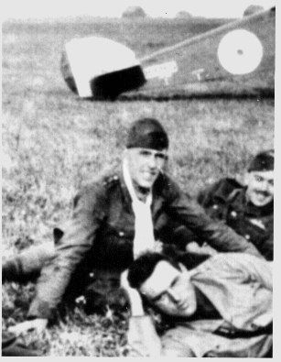

George Robert Craig MC, was born in Co. Durham and was the son of a Darwen doctor. I am sure the family home was up Whitehall Road. He was educated at Haileybury and joined the Lancashire Fusiliers’ Public Schools’ battalion soon after war broke out and when he was barely 17.
The following year he was commissioned as a second lieutenant in the East Lancashire
Regiment.
He was awarded the Military Cross for conspicuous gallantry in France in June 1916. George Craig was later seconded to the Royal Flying Corps and it was while practicing manoeuvres in a Sopwith Camel above Ilford in Essex that he was killed in August 1917. He was just 19 years old.
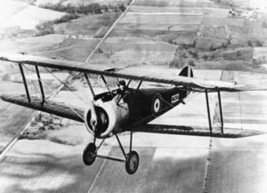
The Sopwith Camel was very difficult to fly. It was so called because of a hump shape behind the propeller. It had a nasty habit of suddenly stalling and it was probably this that led to Craig’s death.
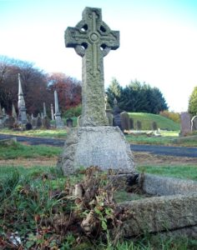
Lieutenant George Robert Craig grave in Section B in Darwen Western Cemetery.
FODC February 2013

